12.46: a) From symmetry, the net gravitational force will be in the direction 45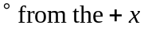-axis (bisecting the x and y axes), with magnitude

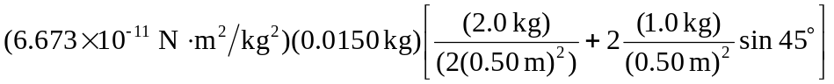
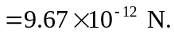

b) The initial displacement is so large that the initial potential may be taken to be zero. From the work-energy theorem,

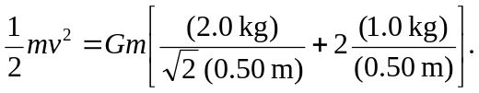

Canceling the factor of m and solving for v, and using the numerical values gives 